Using HashiCorp Terraform, please create the following:

1. Create an IAM role

1. create a granular appropriate that are going to be used ipolicy for your task.

1. Associate this role with the created role.

1. Using this role, create some AWS resources that are going to be used in your infrastructure.

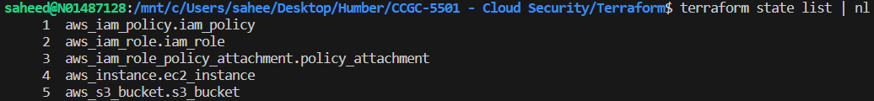

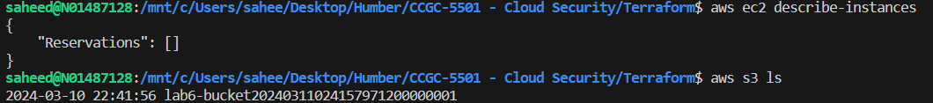

1. Disassociate the policy from the role.
2. Remove the role.